DUC HUAN VU
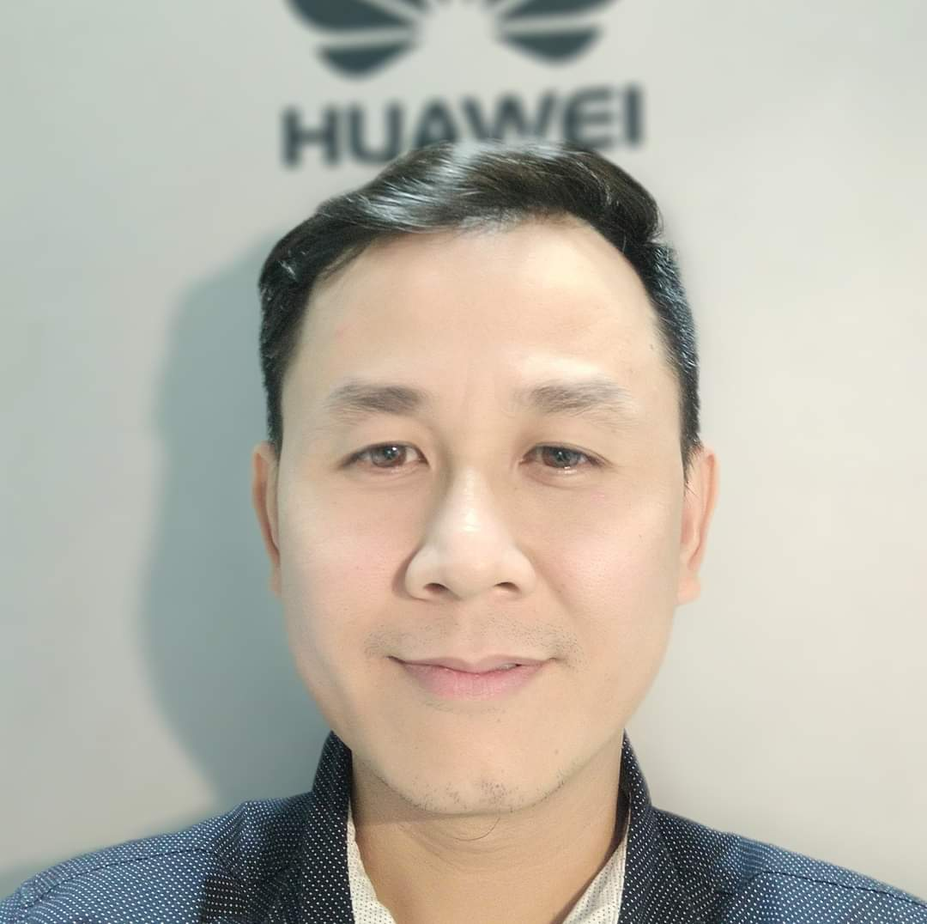
Westminster, CA 92683
huanvu85ca@gmail.com
(657) 346-4533

PROFESSIONAL SUMMARY

Experienced installation and repair technician with work history setting up, troubleshooting and configuring telecommunications equipment. Strong telecom background and 10 year hand-on experience in 2G, 4G, transmission and PSTN network.
Competent Telecommunications Technician bringing 10 years of experience installing voice, data and other systems. Expert at equipment configuration and troubleshooting. Well-organized and resourceful with superior work ethic. Polite and professional worker with exceptional hand-on coordination skills. Proficient in use of software with proven ability to promote effective communication across departments.
AREA OF EXPERTIESE

- Fixed Voice Network
- Telecom transmission
- Networking 2G, 3G, 4G
- Fiber Splicing

ACADEMIC QUALIFICATIONS

Ho Chi Minh City University of Transports - Ho Chi Minh City
September 2003 to April 2009
- Bachelor's in Telecommunications

PROFESSIONAL EXPERIENCE

- TRUONG BUU DIEP FOUNDATION, Dec 2019 to now California
- MEDIA EDITOR
- Developed and managed projects from concept to completion, including storyboards, post-production editing and final delivery formats.
- Planned and scheduled crew members and equipment to accommodate filming schedules.
- Organized assets by collecting data from camera media, transcoding video and audio files and managing file backup to digital asset management system.
- Edited content in real time at events to deliver high-quality media content within short timeframes.

- Viettel Network - Ho Chi Minh city, VietNam March 2015 to October 2019
- MOBILE ENGINEER
- Work with IP team, RF team and field technician to deploy/configure/upgrade base transmission site.
- Work with Service monitor department to resolve the alarm occur in telecom system and incident response.
- Upgrade, maintain, operate BSC system (Nokia and Huawei)
- Viettel Network - Ho Chi Minh City Vietnam November 2014 to March 2015
- SERVER ROOM TECHNICIAN
- Compiled, processed and analyzed test data and results to improve product quality.
- Collaborated with OMC engineers to implement system upgrade, downgrade, expansion, and change project.
- Implemented schematics, diagrams and written and verbal descriptions to effectively solve engineering project issues.
- Make sure the server operates in the proper environment, and store all data clearly and ready in the event of an incident response.

- Viettel Network - Ho Chi Minh city, Viet Nam June 2012 to November 2014
- TELECOM FIELD TECHNICIAN
- Analyzed trouble tickets to determine causes of problems and took appropriate action for resolution (for site equipment, telecom tower, and cellular coverage).
- Installed and configured new devices and system components.
- Coordinated installation of new users and relocations of existing users, on-site customer support.
- Planned layouts and ran cable into buildings and through walls, attics and crawl spaces.
- Planning and executing site deployment and network expansion in the management area.

- Viettel Network - Ho Chi Minh city, Vietnam April 2009 to June 2012
- PSTN VOICE ENGINEER
- Work with tolls and tandems in PSTN network, Huawei CC08 exchange:
- Config/add/delete, and maintain connections and route from 2 tolls to 19 tandems (stand for 19 provinces), responsible for executing any change on the PSTN network.
- Followed standards and procedures to maintain safe work environment.
- Tested equipment and circuits using various tools such as standard hand tools and network diagnostic tools.
- Monitored and analyzed system performance, such as network traffic, security and capacity.

KEY ACHIEVEMENT
- Worked for 10 years in Viettel, the largest telecom service provider in Vietnam.
- Worked as many positions, NOC technician, BSC engineer, Server room technician, field technician, with a 100% success rate.
- Participated in successfully renovating PSTN network in VietNam in 2010.
- Contributed to the successfully deployment of the first 4G network in Vietnam 2015, and upgrade 4G network in 2019, in commissioning team.

CERTIFICATES
- CompTIA A+ certificate
- CompTIA Network+ certificate
- Bachelor of Telecommunication, issued by Vietnamese university

